Shell script 프로그래밍

**ex3-0.sh**

#!/bin/bash

echo “hello wolrd”

exit 0



**ex3-1.sh**

#!/bin/bash

echo “number=”

read num

for ((i=0; i<num; i++)); do

echo “helo world”

done

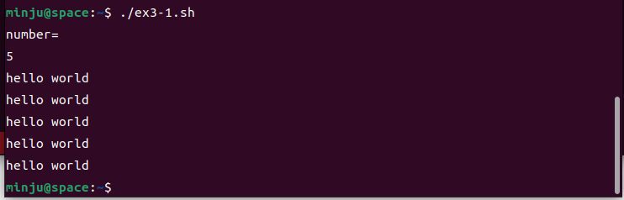

**ex3-2.sh**

#!/bin/bash

echo “num1=”

read num1

echo “operator=”

read operator

echo “num2=”

read num2

if [ “$operator” == “+” ]; then

result=$((num1 + num2))

echo “$result”

elif [ “$operator” == “-” ]; then

result=$((num1 - num2))

echo “$result”

else

echo “invalid operator”

fi

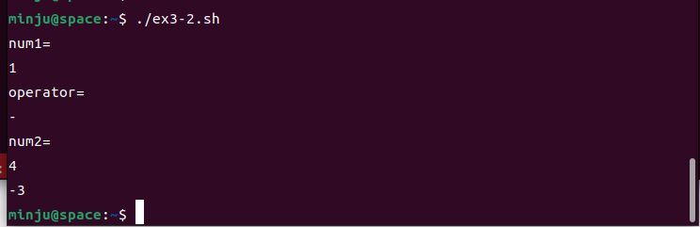

**ex3-3.sh**

#!/bin/bash

echo “weight(kg)=”

read weight

echo “height(cm)=”

read height

BMI=$((weight * 10000 / height * height))

if [ $BMI –lt 105 ]; then

echo “underweight”

elif [ $BMI –lt 250 ]; then

echo “normal weight”

else

echo “overweight”

fi

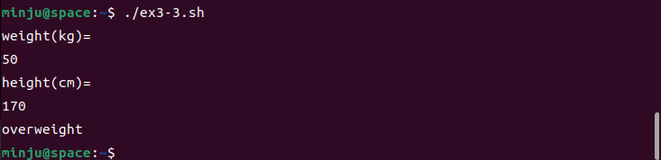

**Ex3-4.sh**

#!/bin/bash

echo –n “Is Linux interesting? (yes / no)”

read answer

case $answer in

yes | y | Y | yesyes)

echo “yes”

;;

no | n | N | nono)

echo “no”

;;

*)

echo “input yes or no”

;;

esac

exit 0

